**Canadore College**

**Assignment of IOS Development**

**(MAD-400)**

**Submitted to: Prof Manhar Kapoor**

**Submitted by: Amandeep Kaur**

**Student id: A00107502**

**Index**

**Topic page no.**

1. Definition of Xcode…………………………………….3-4
2. Capabilities of Xcode……………………………………4-6
3. Xcode interface………………………………………..6-7

**Definition of Xcode:-**

Xcode is one type IDE means integrated development environment. This is first time come in 2003 and created by Apple. Xcode is made for the sake of developing the apps for the Mac OS, IOS and Apple products. After that it release their many version of Xcode but 2021 it release with stable version in which used only new swift language whereas in previous version only c language was used by the user in xcode. Apart from this, Using Xcode we can write the code for the app and making app coupled with debugging as well as compiling the app. In addition to this, we can also upload or submit the app on the Apple app store for marketing with which we can make money through this app.

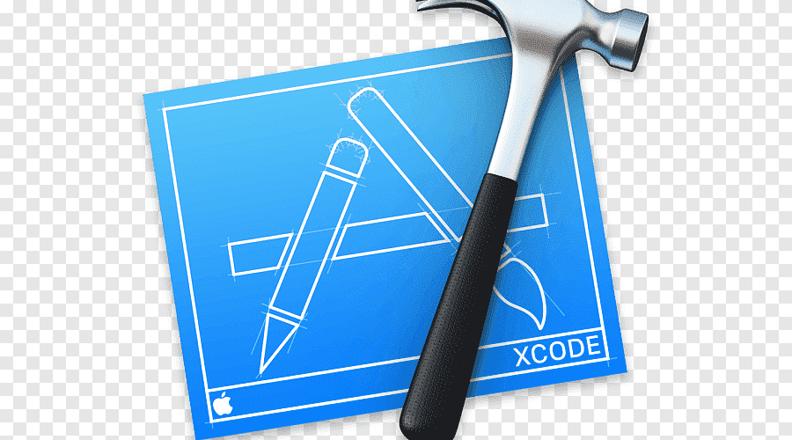

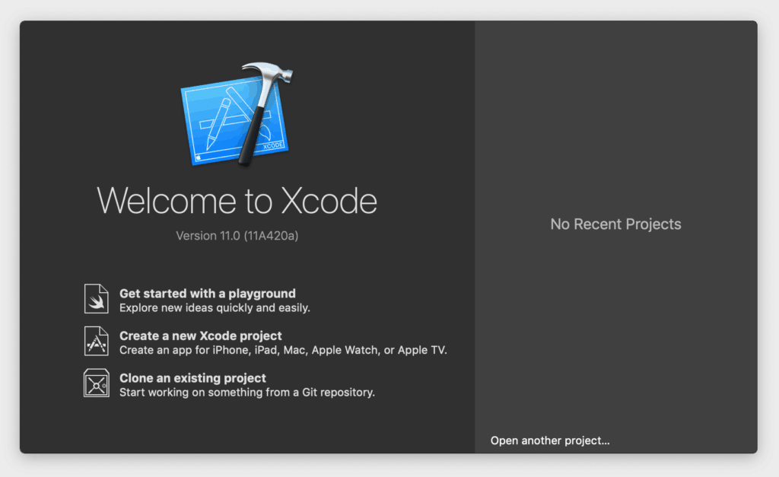

It is easy to use for the making app so new comer can easily learn and develop the app in this Xcode because Xcode is also editor where we can write code in new languages like swift, c ,Objective c, so on. Xcode provides simple templates when we want to create new project in the Xcode Editor then we can use these templates for project and slowly we become familiar with the Xcode very easily.

**Capabilities of Xcode**

Well Xcode is most useful tool or software for the today era and it provides new features or capabilities to the user with which they can make app very fast and easy.

* Xcode works as a one type source editor with which it shows warnings as well as errors to the user before running the app.
* Asset catalog editor is capability of xcode which is used to handle the images resolutions of the similar asset.
* Assistant editor is the feature of Xcode it helps the editor into 2 parts where it create a pane for the showing the important files.
* Open quickly is also one type of tool it is used to open the files in the workplace while selecting the file.
* Xcode provides version editor where running timeline is shown by this editor.
* OpenGL frame capture is feature of xcode which is used to capture the representation of GL frame as well shader information from the ios device.
* Interface builder built-in is easily connecting our interface with source code so we don’t need to write any line of code for testing or designing the interface.
* Xcode run the app in the simulator for the sake of developing the workflow.
* Live issues help to find the mistakes or error of the app before building the app.
* Xcode also gives the signal to fix these mistakes at the time of coding.
* Xcode compilers has LLMV compiler which compile the code very fast and to produce the app as soon as possible.
* Graphical debugger is also help to debug the code or content in Xcode and help us to find the error and fix it and running the programs without errors.
* We can use Xcode or install with the help of virtual box if we don’t have mac otherwise we use macos for running the Xcode. Apart from this, we can use mac clouds for using the Xcode on the window so it provides us many ways to use Xcode.

**Xcode interface:-**

In xcode interface builder is used to make the interface for the app without writing the code. In xcode we just need to drag the buttons ,texts or other function without write any code, we can create the interface design very easily. This interface is archived by cocoa touch objects and this creates the connection between the user interface and code at the time of running the app.

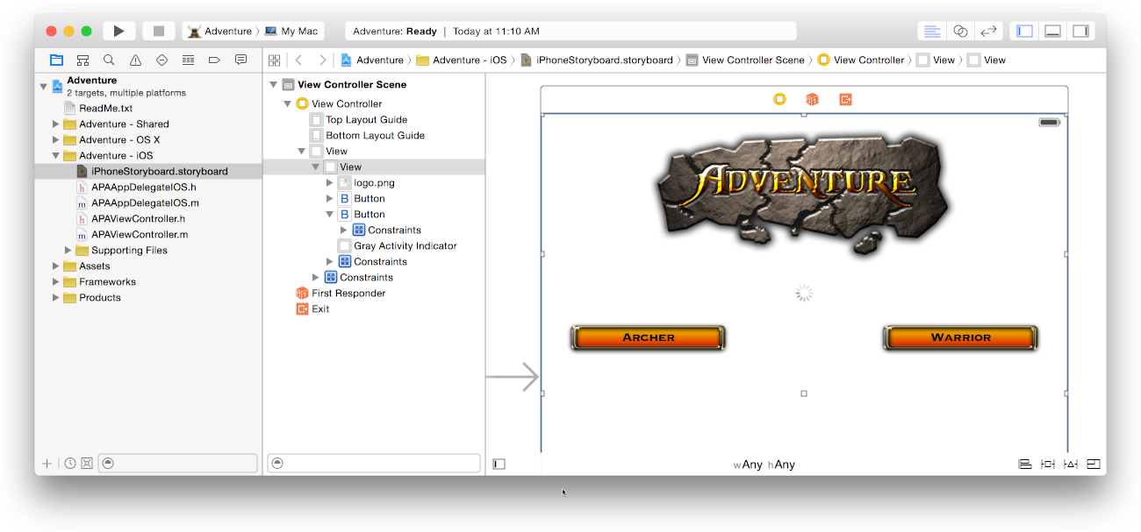

User interface use for the storyboards and other purpose also.

We can create the complete user interface using the storyboard in which we show the views and combine them. But we need to use some controller for making the user interface storyboard.

* Table view controller: in this we can see the table of the view.
* Collection view controller: in this we can see the collection of the view.
* Navigation controller: in this we can see the direction or navigation.
* Tab bar controller: This is also seeing in the xcode.
* Page view controller: in this we can see the page view.
* GLkit view controller: in this we can see the kit and use for this controller.
* Assistant: we use the assistant for providing the logic to the user interface.
* Auto layout: this is helpful to build the interface like button size, text size or we can use the constraints for these adjustments.
* Preview: in this we can see the interface before running the app in real and in landscape mode.